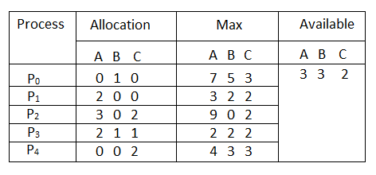

**Question1. What will be the content of the Need matrix?**

Need [i, j] = Max [i, j] – Allocation [i, j]

So, the content of Need Matrix is:

Need Matrix-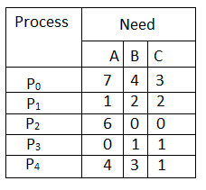

**Question2. Is the system in a safe state? If Yes, then what is the safe sequence?**

Applying the Safety algorithm on the given system,-

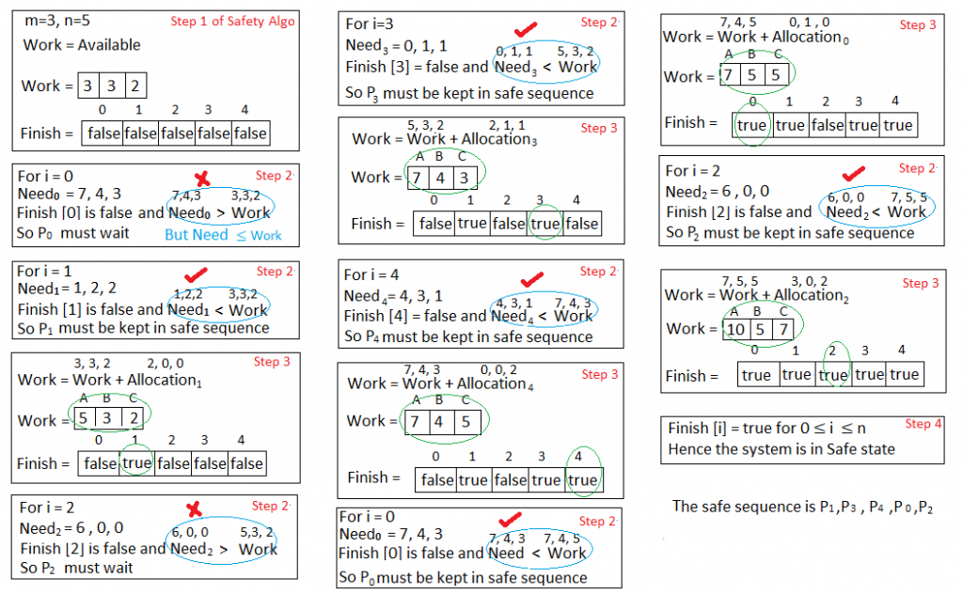

**Question3. What will happen if process P1 requests one additional instance of resource type A and two instances of resource type C?**

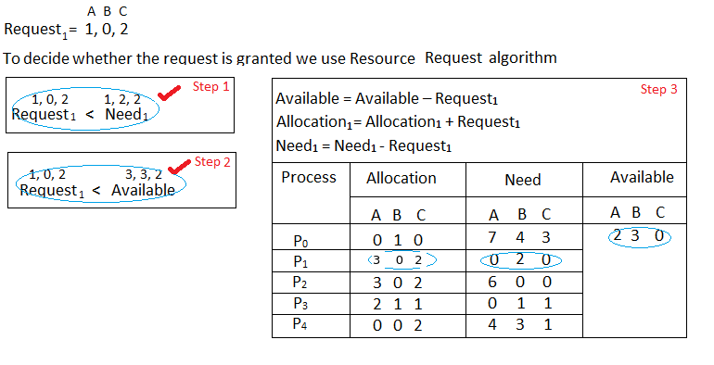

We must determine whether this new system state is safe. To do so, we again execute Safety algorithm on the above data structures.

Hence the new system state is safe, so we can immediately grant the request for 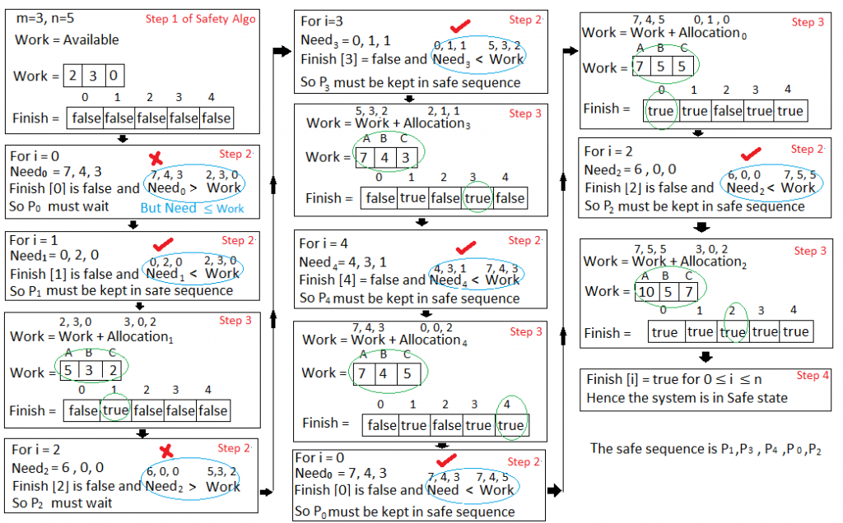process  **P1 .**